https://www.dkfindout.com/us/animals-and-nature/
http://www.kidtopia.info/animals.html

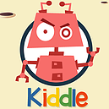https://www.kiddle.co

https://www.factmonster.com/science/animals
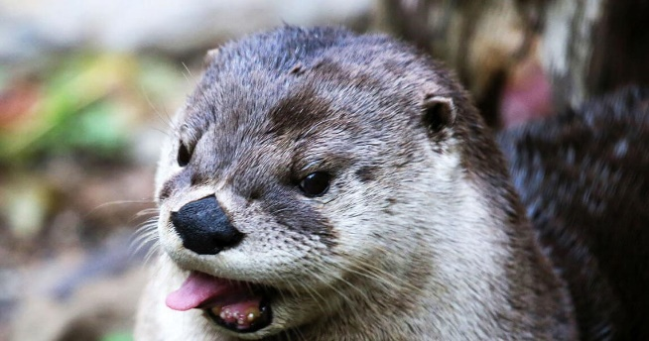
http://www.zooamerica.com/

